Program Review 2022

Consultation Paper
  - GreenPower | July 2022

Contents
Abbreviations 3
1. Introduction 4
1.1. About GreenPower 4
1.2. Purpose of the Program Review and this consultation 4
1.3. How to participate 5
2. How GreenPower works 6
3. Market context 7
4. Short-term changes for 2023 9
4.1. LGC vintage requirement - limiting the validity of certificates 9
4.2. Aligning generator accreditation dates with the CER 10
4.3. Incorporating the RET in GreenPower products 10
4.3.1. Options for recognising the RET 10
4.3.3. Minimum GreenPower percentage 12
5. GreenPower in 2025 13
5.1. Program mission 13
5.2. Program objectives 14
5.3. Additionality 17
5.3.1. The importance of additionality 17
5.3.2. Actions to increase additionality 18
5.4. Actions to increase demand 20
5.4.1. Partner promotion strategy 20
5.4.2. Should GreenPower providers be able to sell other green products? 21
5.4.3. Marketing guidelines and compliance 21
5.5. Actions to improve consumer choice 22
5.6. Generator accreditation 23
5.7. Additional options GreenPower could pursue 24
5.7.1. Retailer star rating system for renewables and emissions 24
5.7.2. Scope 2 emissions fund 24
5.7.3. Real-time 24/7 load-matching 25
6. Did we forget anything? 26

Abbreviations
AEMO Australian Energy Market Operator
CER Clean Energy Regulator
LGC Large-scale Generation Certificates
NABERS National Australian Built Environment Rating System
PPA Power Purchase Agreement
RET Renewable Energy Target
RPP Renewable Power Percentage

Introduction

About GreenPower
The National GreenPower Accreditation Program (GreenPower) is Australia’s premier voluntary renewable electricity accreditation program. The program was established in 1997 and is governed by the National GreenPower Steering Group, which is made up of representatives from participating state and territory Governments. The current program deed between participating jurisdictions appoints NSW Treasury as the Program Manager administering GreenPower.
GreenPower enables households and businesses in Australia to access accredited renewable electricity products. Accredited products are above and beyond the Australian Government Renewable Energy Target (RET), resulting in additional retirement of renewable energy certificates. The program’s strict accreditation and auditing framework mitigates the risk of double-counting of environmental claims and greenwashing.
GreenPower sales must be matched with voluntary surrender of certificates from GreenPower accredited renewable generators (see Section 2). The program accredits eligible GreenPower Generators based on the criteria laid out in its Program Rules, which ensures that every generator delivers a net environmental benefit. The Program Manager also accredits renewable electricity products which are offered by GreenPower Providers (energy retailers and certificate traders).

Purpose of the Program Review and this consultation
Energy markets are in a rapid transition. Policy and market environments have changed significantly since GreenPower’s last program review published in 2015.
The 2021-22 GreenPower program review aims to assess the program’s performance against its current mission and objectives, and identify a pathway for the program to continue to deliver positive outcomes in the energy market to 2030 and beyond.
GreenPower engaged consulting firm Common Capital in 2021 to conduct the Program Review and deliver a report on program performance and recommendations for changes. Common Capital have delivered a report, which is available for download alongside this consultation paper. The report found that there is a continued need for GreenPower to exist, but that the program needs to evolve.
This consultation paper discusses potential ways the program could adapt to market changes, including but not limited to the recommendations made by Common Capital. It provides an opportunity for stakeholders to provide input on the future of the program and implementation of the proposed changes.

There are two time horizons for implementation of program changes:
- 2023: Program alignment and updates:
Building on work that has been undertaken over the past two years, several changes to GreenPower are proposed to commence in 2023. These include aligning generator accreditation dates with the Clean Energy Regulator (CER), reduced certificate validity, and a new definition of GreenPower accredited 100% renewable electricity products.

- 2025: Transition to revised program design:
The more substantial program changes will require further program design work and market research. This is planned to occur over the coming two years, with a tentative commencement of the new program design planned for 2025.
We will take your feedback on board to finalise the design of the 2023 changes and develop a more detailed revised program design for 2025, which we plan to consult on in early 2023.

How to participate
This consultation paper is based on policy development undertaken by GreenPower over the past two years, including Common Capital’s program review report.
This paper should be read in conjunction with the program review report, which is available for download at greenpower.gov.au.
To make a submission, please fill out the response form online at the following linkhttps://oeh.au1.qualtrics.com/jfe/form/SV_6yZxv4em3FP6Xvo
Free form submissions and supporting documents can be uploaded at the end of the feedback form or sent to greenpower.admin@planning.nsw.gov.au.
GreenPower held an online Q&A session on 28 July 2022. Presentation slides from this session are available on the GreenPower website.
Submissions close 5 PM, 22 August 2022.

How GreenPower works
GreenPower products support renewable electricity generators by increasing the demand for the certificates they produce.
An overview of the process is provided in the figure below.
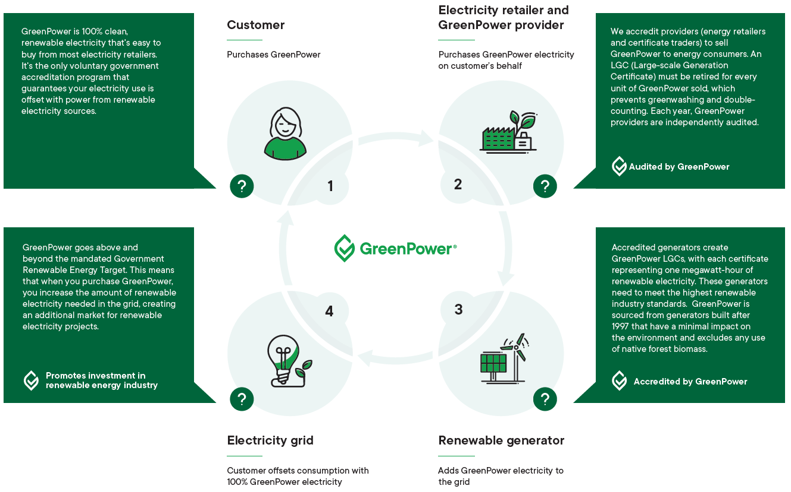
Figure 1: Overview of how GreenPower works

Market context
GreenPower has been highly successful at giving consumers access to accredited renewable energy products, and building trust in the renewable electricity market. GreenPower has shown that voluntary markets provide additional activity beyond regulations, and form an important part of the energy transition.
Some of the objectives of the program, however, have been impacted by market changes in the last few years. GreenPower sales peaked in 2010, and for the past four years we have again seen strong growth. However, this recent growth is not keeping pace with what is needed to drive the rapid transition of Australia’s energy systems to zero emissions.
There are a range of drivers for the above developments. These are listed to illustrate the magnitude and breadth of energy market changes and their impact on GreenPower:
- Uptake of residential solar: Residential and commercial solar uptake in Australia is world leading. For many customers, this means they have achieved their own sustainability goals. However, not all customers can access solar systems and most solar customers still purchase around 50% of their electricity from the grid.
- Renewable energy market penetration: Solar and wind are the lowest cost electricity generation technologies. Barriers to uptake have shifted from financial feasibility to transmission capacity, energy storage and dealing with extreme demand fluctuations.
- The RET has been met: There was sufficient renewable energy capacity to meet the target from 2021 onwards. Certificate prices have halved due to oversupply from a peak of over $80/MWh, but are still higher than expected. An oversupply of certificates would reduce the market impact of GreenPower. The average price of GreenPower has also reduced. There is some uncertainty about the future of the RET, which influences renewable energy investment decisions.
- States and territories now have strong targets: Over recent years, all Australian jurisdictions have adopted strong emissions reduction and renewable energy policies. These use a range of mechanisms to accelerate new renewable and storage capacity construction, and may impact the role of voluntary markets.
- Corporate commitments support new business models: Power Purchasing Agreements and other renewable energy procurement models have matured. These provide new options, especially for large energy consumers, to have a tangible impact. Standards and certifications, such as RE100, SBti, NABERS, GreenStar and b-Corp are contributing to business uptake of low carbon electricity.
- Emergence of carbon offset electricity products: Carbon offset electricity products have emerged as a low cost option and are competing with GreenPower. Most carbon offsets do not contribute to making the electricity grid more renewable.
- Most retailers no longer actively promote and explain GreenPower: Most consumers don’t understand the different electricity products. There is no incentive for energy retailers to promote GreenPower as a best-practice product over cheaper but lower-integrity alternatives such as carbon neutral electricity or old hydro power. As a result, many customers buying carbon neutral offers think they are supporting renewable energy.
Changes to GreenPower are needed to respond to this new market environment and make the program future ready. Future opportunities will be shaped by how GreenPower and other certification programs respond, with some of the most impactful developments being:
- Expected close of the RET scheme in 2030: In addition to growing certificate oversupply, the current certificate trading platform (the Renewable Energy Certificate Registry) would need to be replaced with a successor such as a Guarantee of Origin for renewable electricity. The role of GreenPower in this new scheme, and other renewable fuel schemes, may be different to its current operations.
- Renewable energy making up most electricity generation in 2030: In 2021, the National Electricity Market on the East Coast and South West Interconnected System in Western Australia reached over 31% electricity generation from renewable sources. In its most likely scenario, the Australian Energy Market Operator (AEMO) predicts that renewable energy will make up almost 80% of electricity by 2030.
- Recognising below-baseline and other existing renewable energy capacity: Renewable generators built before the year 2000 were excluded from the RET. However, they generate low cost renewable energy and should be recognised in carbon accounting. There may be a role for GreenPower to support recognition of this renewable generation capacity.
- Renewable energy challenges have changed: There are still barriers to a fully renewable energy system. These include network capacity, energy storage and growing demand. New demand is likely to come from electrifying manufacturing, heating, transport, other existing sectors and new demand for energy products, such as green hydrogen. Many consumers will continue to want to purchase accredited renewable energy products to avoid risks of greenwashing and double counting.
- New renewable fuels are emerging: As discussed in GreenPower’s recent consultation on the Renewable Gas Certification Pilot, several new certifications are being developed for renewable gas, fuels and materials. GreenPower is well placed to support new voluntary markets being established, and help consumers easily identify sustainable products.
Consultation Question
- Do you agree with the above market changes being the main drivers impacting GreenPower sales, public perception and its future role? Are there any other key drivers not included here?

Short-term changes for 2023
This section discusses proposed changes for 2023. These changes have been developed with the input of the GreenPower Stakeholder Advisory Group and other relevant stakeholders.
The proposed changes work within the current program design and are not expected to fundamentally change GreenPower. Instead, they are intended to support our promotional partners and align with electricity carbon accounting changes that were recently made by related programs, such as the National Australian Building Rating System (NABERS) and Climate Active.
We expect these short-term changes will also form part of the 2025 design, however we are considering all options for 2025. If the program is fundamentally changed then not all of the short-term changes may still be relevant, however they are still considered necessary in the near term.

LGC vintage requirement - limiting the validity of certificates
The purpose of this requirement is to ensure the renewable generation date is ‘reasonably close’ to the electricity consumption date, in line with international carbon accounting guidance.
Restricting the validity of certificates would mean that only LGCs created within a pre-determined period are eligible to be surrendered under GreenPower. For example, a 3-year vintage requirement would mean that LGCs older than 3 years cannot to be used for GreenPower. This means that, in 2022, you could no longer use an LGC from 2018 or earlier.
Most GreenPower Providers already operate like this. In the 2020 compliance year, almost 90% of all LGCs surrendered under GreenPower were created in the same year, 98% within 24 months of the settlement period, and only 2% were created in the years 2018 or earlier.
There is flexibility in the definition of ‘reasonably close’.
Proposed short-term change: GreenPower proposes a 36-month vintage requirement consistent with other certification schemes.
Consultation Question
- Should a vintage requirement for GreenPower certificates be introduced, and what should the validity period be? Should it be 36 months, shorter or longer, and why?

Aligning generator accreditation dates with the CER
Generator accreditation dates are currently based on the application date, which is imposing an administrative burden on Providers and auditors. Alignment with the CER accreditation date is proposed to streamline accreditations between the two schemes.
GreenPower proposes to align generator accreditation dates with their CER accreditation date.
Consultation Question
- Do you agree with GreenPower aligning its generator accreditation dates with the CER accreditation date? If not, why?

Incorporating the RET in GreenPower products
GreenPower is voluntary and 100% additional to the mandatory certificate surrenders under the RET. This means that the percentage noted on a GreenPower product (e.g. 100% or 75% GreenPower) is the additional contribution a customer makes.
In early 2020, the RET was met. The Renewable Power Percentage (RPP) sets the percentage for mandatory LGC surrenders under the RET on an annual basis to 2030. The 2022 RPP is 18.64%.
Because GreenPower is additional to the RET, in 2022 a 100% GreenPower customer will be paying for 18.64% under the RET and 100% GreenPower, adding up to a total of 118.64% renewable electricity. In the past, this was not considered an issue because the RPP was low and customers’ aims were to support the renewable industry. Many customers now ask for a product that achieves 100% renewable electricity overall, combining the mandatory and voluntary components.

Options for recognising the RET
GreenPower is considering recognising the surrenders of LGCs mandated through the RET in GreenPower products using the market-based reporting approach described in the Greenhouse Gas Protocol Scope 2 Guidelines. This would align GreenPower with NGERs and Climate Active’s new standards as well as international guidelines such as for the Science-Based Target initiative and RE100. GreenPower Providers were consulted in May 2022 on a variety of implementation options. The following two options were considered most appropriate.
Option A: new 100% renewable energy logo | Option B: include the RET in all GreenPower percentages
- Introduce a new logo for 100% Renewable Electricity, which takes the RET into account.  - Keep all other GreenPower product options additional to the RET and voluntary (e.g. a 50% GreenPower product would not include the RET).  - A 100% GreenPower product (additional to the RET) will continue to be available but Providers may no longer offer it. | - Include the RET in all GreenPower products and percentages.  - The RET percentage (RPP) would be a fixed percentage of approx. 15% to avoid annual changes to products.  - Increase the minimum GreenPower product percentage (currently 10%) to 50% to ensure every product has a real impact. This has to be managed carefully for customers that currently purchase a lower percentage.

Proposed short-term change: GreenPower proposes to proceed with Option A.
Consultation Questions
- Does Option A sufficiently address the demand from stakeholders to recognise the RET for 100% renewable electricity claims? If not, why?

- What are the advantages of Option B? Would fixing the recognised RET percentage be a good solution to deal with the annual changes to the RPP?

- The above proposal is a solution that can be quickly implemented. Should GreenPower consider a different approach in its long-term program design?

Minimum GreenPower percentage
The current minimum GreenPower percentage for products available to households and small businesses is 10%. This minimum percentage was set in the early years of GreenPower to ensure each customer had a reasonable impact and therefore it wouldn’t be greenwashing if they used the GreenPower logo.
An increase to the minimum percentage is especially relevant if the RET is included in all GreenPower product percentages, but this is also being considered as a separate potential change.
Considering the urgency of the transition to renewable electricity, the reduced cost of renewable products and increased renewable generation capacity, the program is considering increasing the minimum percentage to:
- 30%, adding the RET percentage to the current minimum of 10%
- 50%, meaning the voluntary component is always larger than the mandatory RET
- 100%, meaning there would no longer be any products with less than 100% renewable electricity. This would include the RET percentage (RPP).
Similar principles for minimum certified renewable energy use are also being considered by other certification programs, including under Climate Active’s 100% renewable electricity standard.
GreenPower proposes to increase the minimum product percentage to 50% in 2023.
Consultation Questions
- Which minimum percentage do you think is the most appropriate if Option B noted in 4.3.2 is chosen, and why?

GreenPower in 2025
This section discusses the longer-term program design that will be implemented by around 2025, and the vision for GreenPower in future renewable energy and fuel markets. Most of the findings of the program review report relate to this timeframe.

Program mission
GreenPower’s mission statement should summarise the aims and values of the program at a high level. The current program mission is:
To drive investment in renewable energy in Australia, with a view to decreasing greenhouse gas emissions from the generation of electricity, by increasing awareness of, and ensuring consumer confidence in, environmentally sound renewable energy products.
Common Capital suggest that the program’s mission remains relevant, including its focus on electricity. However, voluntary markets for new renewable fuels, energy carriers and enabling technologies are emerging.
New certificate schemes will likely be open to all types of projects, making it hard for consumers to find and choose sustainable options. For example, the CER’s hydrogen guarantee of origin scheme will allow all hydrogen producers to participate, no matter whether producers use fossil fuels or renewable energy. Similarly, a future electricity guarantee of origin could include fossil fuels in an effort to support carbon reporting for all consumers. The corresponding certificates will disclose details about the hydrogen or electricity produced, but consumers may find it difficult to understand them.
An accreditation program like GreenPower could provide a recognisable brand for consumers to know that the product meets their sustainability criteria. This would provide clarity and guidance to consumers, and support new industries develop their social licence to operate.
If the program’s mission is expanded to all renewable energy, GreenPower could support consumer choice and availability of independently accredited renewable energy products across electricity, gas and transport fuels as these become commercially viable. Certifiers of organisations or consumers could reduce their auditing requirements if the customer buys an accredited product.

The following is an illustration of a potential expanded mission:
To drive investment in renewable energy in Australia, with a view to decreasing greenhouse gas emissions from energy use, by increasing awareness of, and ensuring consumer confidence in, environmentally sound renewable energy products.
Consultation Questions
- Should GreenPower’s mission expand to include all forms of renewable energy, for example hydrogen, and is the role of GreenPower the same across different energy carriers?
- Is there anything else that you think should be part of GreenPower’s mission statement?

Program objectives
What a successful GreenPower program looks like in 2030 depends on the role the program wants to play. To ensure the program continues to have a high impact, GreenPower is reviewing the program’s objectives. These should be specific, measurable and align with the program mission.
The current program aims are:
- facilitate the installation of new renewable energy generators across Australia beyond mandatory renewable requirements
- encourage growth in consumer demand for renewable energy
- provide consumer choice for, and increase confidence in credible renewable energy products
- increase consumer awareness of renewable energy and greenhouse issues
- decrease greenhouse gas emissions associated with electricity generation.
How the current electricity-focused objectives lead to market outcomes is illustrated in the program logic on the next page.
A similar program logic could also be developed for renewable gas and hydrogen certification. Common Capital’s report notes that amendments should be considered to make the objectives more outcomes focused, for example setting a target for how many megawatts of new generation capacity the program wants to support by 2030.
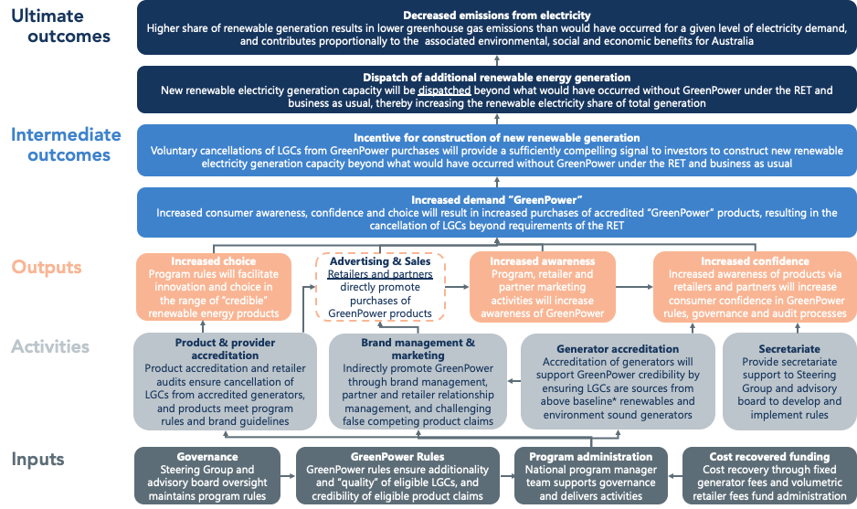
Figure 2: Current GreenPower program logic from Common Capital’s program review report

In reviewing the objectives, the following table lists current and potential new roles for GreenPower that are being considered. These will also be discussed in later sections of this consultation paper and you may wish to respond to this question last.
# | Objective | Score
1 | Increase awareness and demand for voluntary renewable energy products
2 | Decrease nationwide greenhouse gas emissions from energy use
3 | Support new voluntary markets for emerging renewable energy and fuel types
4 | Provide access to renewable energy products that:
5a | - are 100% renewable
5b | - lead to new and additional renewable energy projects being built and dispatched
5c | - are transparent, independently audited and assured
5d | - are affordable
5e | - are aligned with best practice carbon accounting frameworks
5f | - enable consumers to reduce and avoid energy-related emissions
5g | - support best practice in renewable energy development to improve environmental, social and economic outcomes in their host communities
6 | Advocate for consistent and best practice renewable energy and carbon accounting
7 | Advocate for best practice energy product marketing to enable informed decision making by consumers
8 | Other: ______________________________________________________________________

Consultation Questions
- Please give each of the above items a score between 1 and 5 for how important it should be for the development of the program’s mission and objectives, 5 being of the highest importance. You can give the same score to several items.
- If you suggested a change to the program mission, what should be the corresponding objectives? What score would you give them?

Additionality

The importance of additionality
Additionality exists when GreenPower sales lead to new renewable generators getting built. This will not occur in a market with an oversupply of certificates.
As illustrated in Figure 3 on page 20 of the program review report, GreenPower’s impact on accelerating the transition to renewable energy relies on additionality. With the RET having been met in 2021, this additionality is reducing. Nevertheless, current LGC prices are still high and some market reports suggest that the certificate supply is tight, mainly due to growing voluntary purchases.
In the coming years it is expected that a significant oversupply of LGCs will mean there is limited additionality to GreenPower, unless there is a step change in GreenPower sales and other voluntary certificate surrenders, or changes for the program rules that drive additionality.
However, not all consumers want additionality. Especially in corporate carbon accounting, additionality is often not necessary for renewable electricity products to have zero or near-zero emissions. As long as renewable energy is produced, it doesn’t matter whether the renewable generator is ‘new’ or ‘additional’. On the other hand, many small business and residential customers are more interested in the energy sector transition than in emissions reporting, and would like to see their voluntary purchase directly lead to new generators being built. Differentiation of products to reflect this would enable GreenPower to meet different consumer priorities, and could also lead to more attractive incentives for generators.
If a consumer wishes to match 100% of their electricity use with renewable energy, they should be able to do so with a generator that was built many years earlier. An older wind farm’s electricity is still renewable, even if buying certificates from that wind farm does not lead to the construction of a new generator. This would also be the case for electricity generators built before 1997, which are not eligible to create LGCs under the RET. However, this consumer’s purchase is not as impactful as a purchase that leads to additionality and this should also be recognised.
Common Capital’s report notes that GreenPower should focus on additionality as its core objective, and that existing generators should not be able to participate in GreenPower. The program needs to carefully define ‘existing’ and ‘additional’ generators, and what recognition the program provides for both categories.
GreenPower’s role will also depend on whether there is a national Guarantee of Origin for renewable electricity that could be used for non-additional renewable purchases.
Consultation Question
- Should GreenPower focus on maximum additionality, electricity carbon accounting, or should both types of products be supported?

Actions to increase additionality
Section 5.3.1 asked the fundamental question of what market change and consumer choices GreenPower should support. If aiming for additionality there are different ways GreenPower could change its rules to support new generators getting built.
There are several options to increase additionality. From least to most restrictive, the measures discussed in the program review report are: LGC vintage requirements, generator age limitations, and only accepting new generators.
LGC vintage requirement - limiting the validity of certificates
As discussed in Section 3, this option proposes a restriction of LGC validity. This would mean that only LGCs created within a pre-determined period are eligible to be surrendered under GreenPower.
This requirement would only lead to additionality if there is a shortage in new certificates going forward. For example, if there are not enough LGCs in 2022, but there are a lot of unused LGCs from earlier years. Considering the large number of new renewable generators in the pipeline, and the RET already having been met, we do not believe that this new requirement would lead to additionality for GreenPower.
However, it would ensure the generation occurs reasonably close to the date of electricity use. This is recommended by international carbon accounting guidance and required under the Climate Active certification program.
Consultation Question
- Should a vintage requirement for GreenPower certificates be considered in the long-term design of GreenPower, and why?

Generator age limitation
Another option to consider is for GreenPower to only recognise certificates from generators which were built within the previous few years. This significantly shrinks the number of eligible GreenPower generators and certificates. For example, only three of the top ten generators used for GreenPower surrenders in 2020 were built in the last five years. A similar requirement is being considered for the definition of ‘renewable hydrogen’ in Europe.
The program review report (p. 43) notes that a rolling vintage restriction could force retailers to contract certificates from new generators and result in additionality. However, the report also notes that this is a theoretical assumption and that, in practice, the market is too complex to assume that this would work for certain.
Generator investors generally need a 10 -15 year commitment for the income from GreenPower certificates to be considered a reliable revenue stream. This means generators may no longer get sufficient benefit from GreenPower accreditation if they can only sell certificates for five years or less. A generator age limitation would likely increase the cost of GreenPower as it would be more difficult to find accredited certificates, making GreenPower less affordable for consumers.
These complexities mean that even a rolling generator age limit of 3 or 5 years before the current reporting year would still need careful design and testing to drive additionality.
Consultation Question
- Should GreenPower consider a generator age limit approach? If so, why?

Certification of new projects only
Another option is for GreenPower to only consider accrediting generators that are built in relation to a GreenPower purchasing agreement. This is similar to the existing GreenPower Connect product. The program review report (p. 44) suggests that this restriction would lead to the highest level of additionality.
This option would mean that each GreenPower Provider would need to show how their purchase of certificates has helped build a new generator. GreenPower would no longer need to accredit generators, but would instead certify contracts between Providers and new generators for a specific volume of certificates. This would allow long-term offtake agreements that can be considered by investors as a reliable revenue source.
This pathway would be a significant change in how GreenPower operates and interacts with the market and stakeholders. It would likely increase the cost of GreenPower in the short term due to the strict requirements of having to support a new generator, and smaller providers may need support to access certificates. Further work would be required to design this change.
While a short term drop in sales is likely due to the increased cost, this option could achieve high impact in the mid- to long-term, and strengthen the public perception that GreenPower is best practice renewable energy purchasing. It offers the strongest value proposition for additionality.

Consultation Questions
- Should GreenPower restrict participating generators to new projects only? And if yes, why?

- How well would this option deliver on the GreenPower mission and objectives? Does this differ for households, small and large businesses?

Actions to increase demand
Several of the current program objectives relate to increasing GreenPower demand. Growing demand means more consumers are aware of the program, believe in the impact of buying GreenPower to accelerate the energy transition, and more renewable generators get built.
The program’s objectives therefore lead to the following marketing objectives:
- Drive uptake of GreenPower accredited renewable energy products
- Raise awareness of GreenPower among residents and small businesses
- Ensure GreenPower is seen to be the most trusted renewable energy program nationwide
GreenPower conducts marketing activities using online tools such as its newsletter, website and social media and sponsoring business and community events with GreenPower. In addition, GreenPower partners with organisations such as councils or NGOs which play an important role in educating and informing consumers on renewable electricity and GreenPower.
The program relies heavily on GreenPower Providers’ point of sale marketing and advertising activities to reach potential customers. This main marketing channel has eroded with the rise of carbon neutral electricity products which are marketed heavily by retailers above GreenPower.
The program review report discusses different options for GreenPower to drive demand and make its accredited products accessible to energy consumers. These are discussed below.

Partner promotion strategy
The program review report proposes (p. 50) to broaden the distribution channels of GreenPower, enter into partner promotion strategies, increase visibility and the level of detail in publicly available sales data.
For an expanded marketing strategy and new partner promotion model, GreenPower would need to increase its resourcing and budget. This would reduce the program’s reliance on energy retailers as the main promoter of GreenPower, and enable it to represent the renewable energy industry and consumers in the public domain.
Consultation Questions
- Which organisations would be most suited to partner with GreenPower to drive awareness and uptake of GreenPower, and why?

- Would you support GreenPower increasing program fees so that the program manager can increase its marketing and promotional activities?

Should GreenPower providers be able to sell other green products?
GreenPower’s current program rules don’t allow the promotion of different renewable energy and other ‘green’ products, however this is no longer practicable. Retailers are now offering a range of products with different social and environmental attributes, and GreenPower should be able to be sold as part of a broader product range. Changes to the program rules are required to allow this.
This is an opportunity to also review whether GreenPower wants to continue working with providers that offer products that are not best-practice, such as carbon offset electricity products. It can be argued that such products have a negative impact on consumer understanding of, and support for renewable energy. Carbon neutral and non-accredited renewable electricity products are often offered at little or no additional cost, and directly compete with GreenPower.
Feedback from consumers and consumer advocates shows that these products cause confusion, and that consumers cannot distinguish between carbon neutral and renewable energy products.
Consultation Question
- Should retailers be blocked from joining GreenPower if they sell green products that are not linked to renewable energy generation?
- What other changes to the program could provide the same level of clarity for consumers?

Marketing guidelines and compliance
Marketing rules and guidelines for generators, providers and third parties are outlined in the program rules and Brand Usage Guidelines. Marketing materials to promote GreenPower have to be submitted to the program manager for approval and compliance checks are part of the annual audit. This is important to ensure marketing activities are appropriate and accurate, and to maintain the integrity of GreenPower’s brand.
There is a high level of compliance with GreenPower’s marketing requirements. However, in recent years there have been increasing numbers of customer complaints about it being difficult to sign up to an advertised GreenPower product.
Some GreenPower Providers actively divert customers away from GreenPower. This is done, for example, by requiring a phone call to sign up to GreenPower while customers can tick a box in the online sign up process to get other green products; or by call centre staff telling customers that carbon offsets are a better option than GreenPower. Customers trying to sign up have also reported that retailers claim their current offers are incompatible with GreenPower, even if they offer a GreenPower product.
Additionally, there is confusion among most customer types about what different ‘green’ products mean, and many customers think that carbon offset products are renewable energy products, which is not the case. This is due to a general lack of understanding of carbon and energy markets as well as unclear or insufficient information provided by electricity retailers.
The program review report suggests GreenPower take a leadership role in differentiating renewable electricity from carbon neutral electricity, and clearly advocate for best practice by electricity retailers. This stronger position could take the form of advertising campaigns by GreenPower against carbon neutral products, and stricter rules for retailers that participate in the program.
Consultation Questions
- Should GreenPower set strict requirements for how providers promote GreenPower and onboard GreenPower customers, i.e. how easy it is to get GreenPower?

Actions to improve consumer choice
Providing consumers with access to renewable electricity products is one of the objectives of GreenPower. While GreenPower is available to almost any electricity user in Australia, some do face challenges to access GreenPower.
Consumer groups which are part of embedded networks may not be able to get GreenPower, such as some residents in apartments and individual shops in shopping centres. There are accredited products for embedded network customers, however these cover only a fraction of the market. Alternatively, customers can buy de-coupled GreenPower, where they buy the renewable energy certificates separate to the electricity. However, this option is generally only open to large energy users because it is uneconomical for providers to sell small quantities.
The program review report suggests that other organisations, such as councils, supermarket chains or banks, could offer GreenPower in small quantities. They would act as aggregators to bundle demand as they don’t rely solely on certificate sales for their revenue. In particular if GreenPower moves toward a ‘new-projects only’ approach, demand aggregators would be needed to ensure small customers can access GreenPower.
Consultation Questions
- Are there any other customer segments that are unable to access GreenPower?
- How can GreenPower support more flexibility for small energy users to purchase small quantities of GreenPower, such as for embedded network customers?

Generator accreditation
GreenPower has strict criteria for generators that wish to become accredited under the Program, in addition to Clean Energy Regulator (CER) requirements for participation in the RET. Each application is assessed against the criteria in the program rules to confirm that the generator has a net environmental benefit.
This was critical in the first decade of the Program’s operation, when Australian planning laws were inconsistent and often had only minimal requirements. However, the planning system has improved significantly. Most generators now meet GreenPower’s requirements if they use an eligible technology, simply by complying with local planning requirements.
GreenPower could therefore replace its project by project assessment with a broader, technology-based approach, for example by automatically accrediting all solar and wind projects. Technologies like bioenergy and large hydro power could still be eligible to apply, or could be categorically excluded to reduce program administration costs.
Alternatively, GreenPower could create stricter requirements in an effort to drive best practice renewable energy development. To electrify most of Australia’s energy use from heating, transport and industry, many more renewable generators will need to be built in the coming decades, along with transmission power lines and storage infrastructure. A GreenPower generator standard could help protect the social licence for renewable generators to operate by requiring appropriate environmental and biodiversity assessment, community consultation and benefits, water and waste management, supply chain emissions, and more.
GreenPower could work with project developers, Government policy makers, land holders and communities to develop and continually improve best practice standards. To be successful, the Program would need to engage with generators earlier than is currently the case, and it would need to align with national, state and territory policies, such as Renewable Energy Zones.
Consultation Questions
- Should GreenPower reduce its accreditation requirements, or make them stricter; and what do you think is the benefit of either approach?
- What are the most important aspects that GreenPower should consider in its generator assessment?

Additional options GreenPower could pursue

Retailer star rating system for renewables and emissions
A renewable energy and emissions performance rating for energy retailers could complement GreenPower’s current accreditation. It could provide an independent reference for consumers wishing to make more sustainable choices even if they are unable or unwilling to pay for GreenPower accredited electricity. The program review report outlines this option on pages 46-48.
Such a rating could provide a simple, objective, and credible framework for customers to choose between otherwise equivalent products, similar but more quantitative than the Green Electricity Guide published by Greenpeace. To be meaningful, participating retailers would need to disclose their market hedging contracts and generation portfolios, which would allow GreenPower to assess their overall environmental performance.
Consultation Questions
- Do you see value in an official environmental rating for electricity retailers, and in GreenPower developing this rating?

- How could this be made administratively efficient and commercially attractive for retailers that perform well environmentally?

Scope 2 emissions fund
An alternative to the current GreenPower design is the establishment of an electricity emissions fund committed to driving investment in renewable energy development. Such a fund would collect funding from GreenPower customers to directly invest in generators. The concept is outlined in Policy Option 6 of the program review report. For example, it could pool funding from public and private organisations, and individuals, to fund reverse auctions for new renewable energy generation capacity. This option could achieve a high level of additionality but it is also highly complex to establish and administer.
Consultation Questions
- What would the minimum fund size need to be to provide material incentives for industry participation in auctions?
- How could the fund’s emissions reductions be allocated to investors or GreenPower customers’

Real-time 24/7 load-matching
Large (often multi-national) organisations such as Google are considering how they can cover their electricity load with 24 / 7 renewable electricity. In Australia, the roll-out of more renewable generation as well as storage may make this proposition more relevant in the next decade. Technology solutions already exist that can assist with this process.
Consultation Question
- How important is 24/7 renewable electricity coverage to businesses in Australia? Are companies prepared to pay more than normal GreenPower for a 24 / 7 load-matched product accredited by GreenPower?

Did we forget anything?
Please let us know if you have any other suggestions or feedback, both regarding the current program and its potential future design.
Consultation Question
- In your experience with GreenPower, is there anything else that could be done to improve the efficacy and effectiveness of the program?

Thank you
Thank you for taking the time and providing feedback to this consultation.
Your input will help us continue to provide trusted, impactful renewable energy choices for consumers across Australia.

https://www.greenpower.gov.au/documents/brand-and-marketing-guidelines

