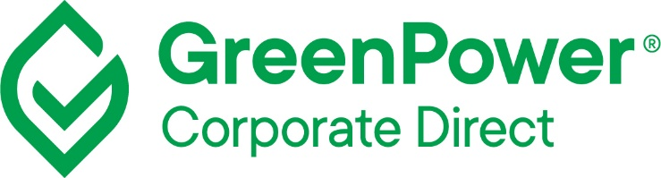

Application & assessment form
Information submitted for GreenPower Corporate Direct Product assessment

Date: XX/XX/202X
Participant: Participant Name
Please send the completed application to greenpower.admin@planning.nsw.gov.au

 | Applicant Details | Included – for internal use
Company Name: |  | /
ABN |  | /
Address |  | /
Contact details  (Name, Title, Phone, Email) |  | /
Proposed start date |  | /
Proposed end date | {date / ongoing} | /
Estimated annual electricity usage |  | /
Planned number of LGCs for surrender* |  | /
Targeted GreenPower % |  | /
Details of where RECs will be sourced for GreenPower Corporate Direct | {short description of how LGCs will be procured} | /
Promotional materials, if available: | {Draft marketing materials, if available} | /
Name(s) and ABN(s) subsidiary company which you apply for to be participating in Corporate Direct.  Please note only companies which are considered part of the corporate group according to section 46 of the Corporations Act 2001 are eligible. |  | /
Participant Agreement executed? | {executed/To be executed} | /
Viewing rights to REC registry account where GreenPower LGCs will be held and surrendered for Corporate Direct will be provided to GreenPower |  | /
If an existing GreenPower Provider is acting as an agent, on your behalf, please provide  - Provider name  - Provider contact details |  | /
Renewable hydrogen projects in Australia are exempt from the GreenPower program fees for Corporate Direct products until and including 2030.  If you are applying for this exemption, please provide project details. |  | /

*Please note, to be eligible for GreenPower Corporate Direct, participants must surrender at a minimum the equivalent to at least 10 per cent of the organisation’s electricity consumption. If they are not, participants must surrender further LGCs to the equivalent of at least 10 per cent to use the GreenPower logo.

Date ___________________________ Signature ___________________________

